/*

Name: Harsh Singh

Roll NO:1262

Unit:1

**Program: Insertion Sort**

*/

#include<iostream>

using namespace std;

int main()

{

int n,i;

int A[10];

int tmp,loc;

cout<<"***Insertion Sort***"<<endl<<endl;

cout<<"Enter the size of array:";

cin>>n;

cout<<"Enter the elements of array:";

for(i=0;i<n;i++)

{

cin>>A[i];

}

cout<<endl<<endl;

cout<<"Orignal Array is:";

for(i=0;i<n;i++)

{

cout<<A[i]<<" ";

}

//Insertion Sort

for (i=1;i<n;i++)//iteration loop

{

tmp=A[i];

loc=i-1;

while(tmp<A[loc] && loc>=0){

A[loc+1]=A[loc];

loc=loc-1;

}//end of while

//At this stage a space is available for tmp

A[loc+1]=tmp;

}//end of for i loop

cout<<endl<<"Sorted Array:";

for (i=0;i<n;i++){

cout<<A[i]<<" ";

}

}

**Output:**

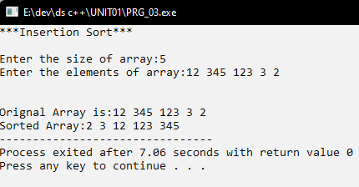

/*

Name: Harsh Singh

Roll NO:1262

Unit:1

**Program: Shell Sort**

*/

#include<iostream>

using namespace std;

int main()

{

int n,i;

int A[10];

int tmp,j,gap;

cout<<"***Shell Sort***\n\n";

cout<<"Enter the number of elements in the array:";

cin>>n;

cout<<"Enter the elements"<<endl;

for(i=0;i<n;i++){

cin>>A[i];

}

cout<<endl<<endl;

cout<<"Orignal Array: ";

for(i=0;i<n;i++){

cout<<A[i]<<" ";

}

//Shell sort

for(gap=n/2;gap>0;gap=gap/2)//Iterations for increment sequence

{

for(i=gap;i<n;i++){

tmp=A[i];

for (j=i;j>=gap && tmp<A[j-gap];j-=gap)

{

A[j]=A[j-gap];

}//end of j loop

A[j]=tmp;

}//end of for i loop

}//end of loop

cout<<endl<<endl;

cout<<"Sorted Array: ";

for(i=0;i<n;i++){

cout<<A[i]<<" ";

}

}//end of main

**Output:**

